Java 3 Activity 4 Task 4

30003389 – Kyer Potts

Table of Contents

Table of Contents i

PathTest 1

PathArray 2

Person Class Serialization 3

# PathTest

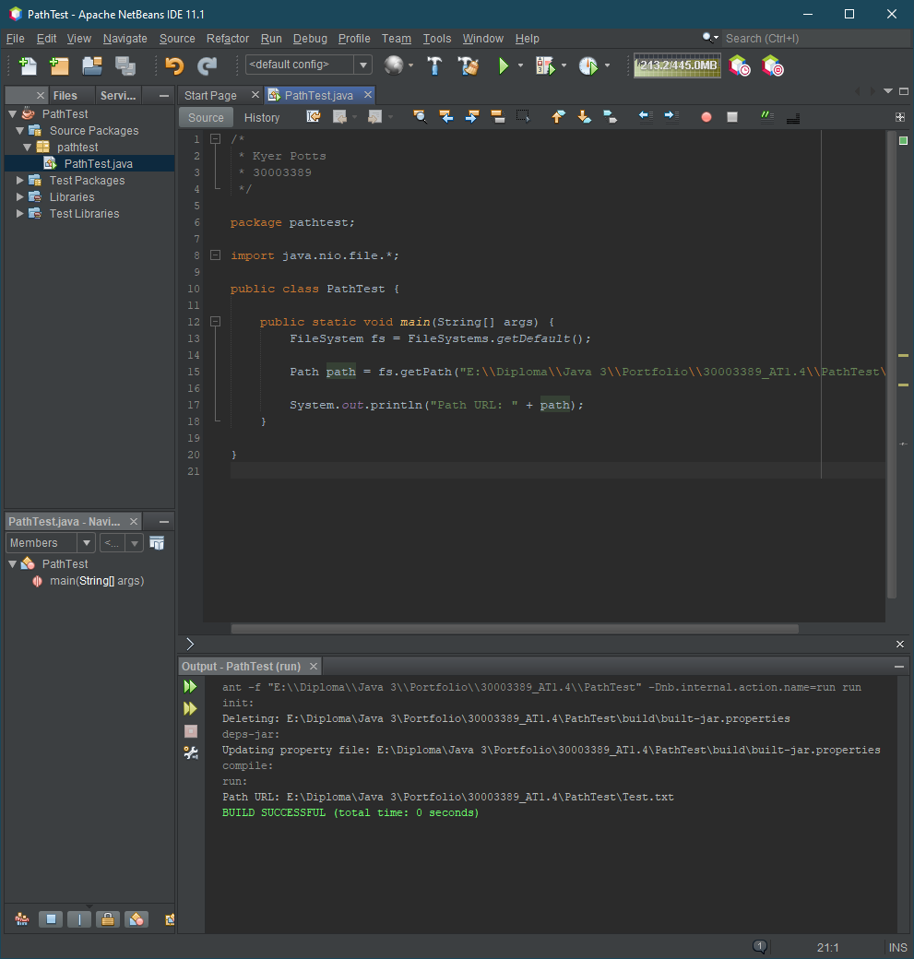

# PathArray

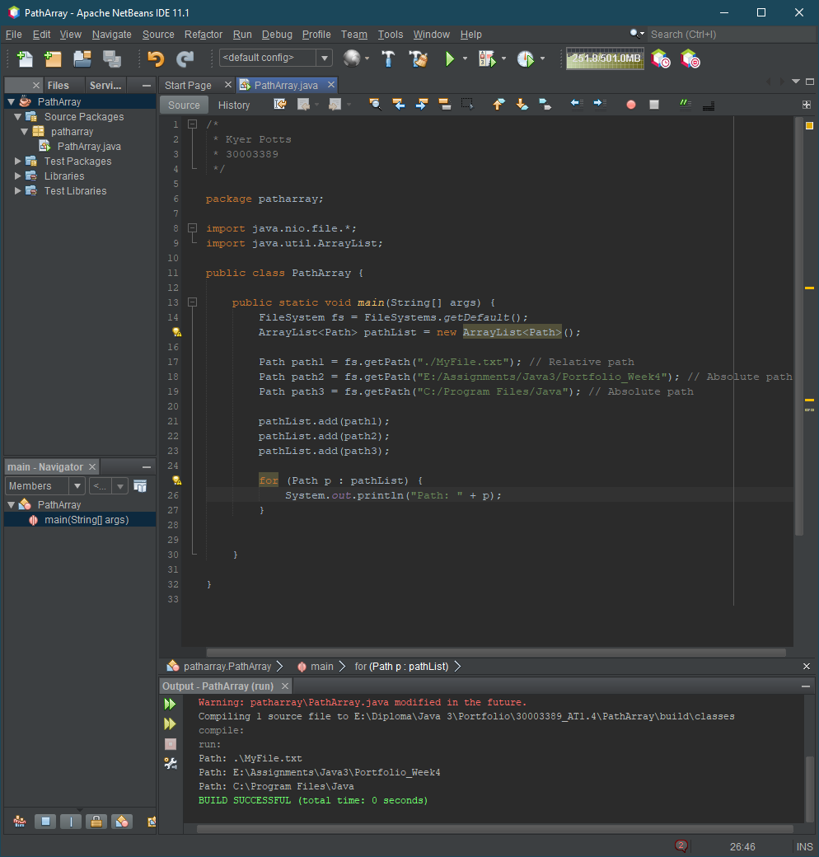

# Person Class Serialization

